Project Concept: STEMM Lab – A Real-World STEMM Games
STEMM Lab is a mobile app that transforms real-world physical activities into engaging, game-based Science, Technology, Engineering, Mathematics, and Medicine (STEMM) learning experiences. Students complete hands-on challenges using everyday materials, their bodies, and their surroundings, while the app captures data using the phone’s camera, sensors, GPS, timers, and analytics.
For each activity, students upload videos, record results, rate the activity, and comment on outcomes, with GPS location tagging enabled. Teams compete on leaderboards, receive timed challenges, and iteratively improve their designs like real scientists and engineers. The app will have appropriate screens for each activity.
This app will be designed for upper Primary School and lower High School students.

App Start-Up
- Enter Team Name
- Enter First Name of Each Team Member
- Grade or Year Level
- Team Discriminator: Assigned by app

Contents
Project Concept: STEMM Lab – A Real-World STEMM Games 1
Engineering Challenges 2
Activity 1: Parachute Drop Challenge 2
Activity 2: Sound Pollution Hunter 4
Activity 3: Hand Fan Challenge 6
Activity 4: Earthquake-Resistant Structure 8
Health and Medical Sciences 10
Activity 5: Human Performance Lab – Stretch Speed & Gracefulness 11
Activity 6: Reaction Board Challenge 13
Activity 7: Breathing Pace Trainer 15

Engineering Challenges

Activity 1: Parachute Drop Challenge
(Engineering + Physics)
Overview
Students design, build, and test a parachute for a small toy to reduce its landing speed and impact force. Teams iterate their designs under time and material constraints, aiming to achieve the slowest and safest landing within a target area.
Equipment
- Mobile phone with STEMM Lab app
- Small toy (e.g. army toy soldier)
- Table or elevated surface
- Paper or plastic
- String
- Scissors
- Tape
Instructions
- Drop the toy without a parachute and record the fall (baseline test).
- Build a parachute using provided materials.
- Drop the toy from the same height and record the fall.
- Review speed and landing accuracy results in the app.
- Redesign and test up to three prototypes within 20 minutes.
- Upload videos, results, and team reflections.
Diagram
- Toy attached to parachute
- Drop height marked
- Target landing zone shown on floor
(Simple labelled sketch)
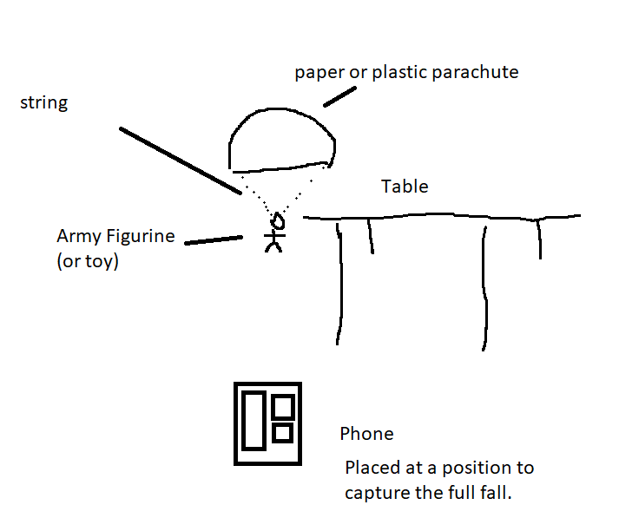
Write-up (on paper):
Predict which parachute design was the best.
Sketch each of the design
Recode the times of the design
Were you correct in timings?
What design was the easiest to make?
 | How will it take to hit the ground? | Time (time to first hit the ground) | Were you right? | Time (time from first hitting the ground and stop moving) – need slow motion.
Action 1 (e.g. No parachute as the baseline)
Action 2 (e.g. use plastic with four corners tied to the toy)
Action 3
Discussion: Parachutes and Forces (Plain Language)
Gravity pulls objects downward, causing them to speed up as they fall. A parachute increases air resistance (also called drag). Drag acts upward, opposing the motion and slowing the fall. A slower fall reduces the force when the toy hits the ground, making the landing safer. Engineers improve parachute designs through repeated testing and redesign.

Forces Acting on the Toy
Force | Formula
Downward (weight) | $$\text{Weight}=\text{mass}×g$$
Upward (drag) | Drag force from the parachute
Net (total) force | $$\text{Net Force}=\text{Weight}-\text{Drag Force}$$
Newton’s Second Law:
$$\text{Net Force}=\text{mass}×\text{acceleration}$$

Calculations
Step 1: Measure the Drop Height
Measure the height of the table or drop surface (distance fallen).
Step 2: Measure the Time
Drop the toy (do not throw it).
Record the time taken to first hit the ground using a phone timer or video.
Step 3: Calculate Final Velocity
Since the toy is dropped, the initial velocity is 0 m/s.
$$\text{Final velocity}=\frac{\text{distance}}{\text{time}}$$
Example:
$$1.0\text{ m}/0.5\text{ s}=2.0\text{ m/s}$$
Step 4: Calculate Acceleration
$$\text{Acceleration}=\frac{\text{Final velocity}-\text{Initial velocity}}{\text{time}}$$
Initial velocity = 0:
$$\text{Acceleration}=2.0/0.5=4.0\text{ m/s²}$$
Step 5: Calculate Net Force
$$\text{Net Force}=\text{mass}×\text{acceleration}$$
Example (mass = 0.20 kg):
$$\text{Net Force}=0.20×4.0=0.8\text{ N}$$
Step 6: Calculate Drag Force
Calculate the weight:
$$\text{Weight}=\text{mass}×g=0.20×9.8=1.96\text{ N}$$
Calculate drag:
$$\text{Drag Force}=\text{Weight}-\text{Net Force}=1.96-0.8=1.16\text{ N}$$

G-Force (Stopping Acceleration)
G-force describes how quickly the object slows down when it hits the ground. It is measured in multiples of $g=9.8\text{ m/s²}$.
Using the STEMM App Slow-Motion Video:
Identify the moment the toy first hits the ground.
Measure the time taken for the toy to stop moving (contact time).

Case 1: Object Does Not Bounce
Object goes from impact speed downward to 0 m/s.
$$Δv=v_{\text{impact}}$$
G-force formula:
$$g\text{-force}=\frac{Δv}{t_{\text{contact}}}÷9.8$$
Example:
Impact speed = 2.0 m/s
Contact time = 0.05 s
$$g\text{-force}=2.0/0.05÷9.8≈4.1 g$$

Case 2: Object Bounces
Object goes from impact speed downward to upward velocity at separation ($v_{\text{up}}$).
$$Δv=v_{\text{down}}+v_{\text{up}}$$
G-force formula:
$$g\text{-force}=\frac{Δv}{t_{\text{contact}}}÷9.8$$
- Finding $v_{\text{up}}$if rebound height is unknown:
Measure time to maximum height after bounce ($t_{\text{up}}$) using slow-motion video.
Calculate upward velocity:
$$v_{\text{up}}=g⋅t_{\text{up}}$$
- Example:
Impact speed downward: 2.0 m/s
Time to max height after bounce: 0.15 s → $v_{\text{up}}=9.8⋅0.15≈1.47\text{ m/s}$
Contact time: 0.02 s
$$Δv=2.0+1.47=3.47\text{ m/s} \\ g\text{-force}=3.47/0.02÷9.8≈17.7 g$$
- Observation: Bouncing increases g-force because the velocity change during contact is larger.

Case | Δv | g-force formula
No bounce | $$v_{\text{impact}}$$ | $$g=v_{\text{impact}}/t_{\text{contact}}÷9.8$$
Bounce | $$v_{\text{impact}}+v_{\text{up}}$$ | $$g=(v_{\text{impact}}+v_{\text{up}})/t_{\text{contact}}÷9.8$$
Tips for slow-motion video:
- Use a ruler in frame for scale
- Identify first contact for contact time
- Identify when object leaves surface for bounce calculation

Typical G-Force Ranges and Injury Risk
G-Force Range | Examples | Likely Effects
1–5 g | Standing up quickly, elevators, amusement rides | No injury
5–10 g | Hard falls while running, minor car braking | Possible bruising or strains
10–30 g | Sports collisions, bicycle crashes, car crashes with seatbelts | Serious injuries possible (broken bones, concussions)
30–50 g | Severe car crashes, falls onto hard surfaces | High risk of severe injury
50+ g | Very sudden stops with no cushioning | Life-threatening injuries likely
Important: Duration matters. A brief spike can be survivable, while sustained g-forces are more dangerous.

Student Focus
Primary School students
- Measure time
- Calculate final speed
High School students
- Calculate final velocity
- Calculate acceleration
- Calculate net force
- Calculate drag force
- Calculate g-force

Curriculum Links
Science
- ACSSU076 / ACSSU117 – Forces affect motion
- ACSIS124 – Planning and conducting investigations
- ACSIS126 – Analysing patterns in data
Design & Technologies
- ACTDEP036 – Generate, test, and improve solutions
Mathematics
- ACMMG108 – Measuring speed
- ACMSP147 – Comparing data and averages

Activity 2: Sound Pollution Hunter
(Environmental Science)
Overview
Students measure and compare sound levels in different classroom activities.
Equipment
- Mobile phone with STEMM Lab app
Instructions
- Measure noise from different actions (dropping objects (pens, books) talking, walking, stamping your feet).
- Record sound levels and locations.
- Map loud and quiet zones.
Diagram:
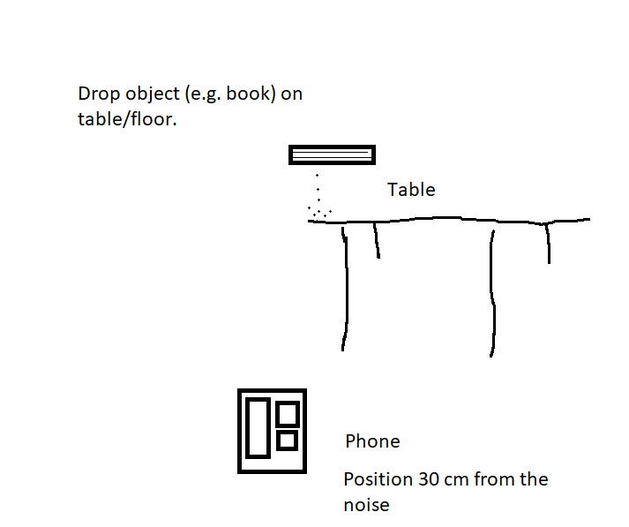
Write-up (on paper):
Predict which action created the loudest sound
Record the results
Were you right?
Any surprises?
Should we wear ear muffs in your classroom?

 | Prediction (louder or softer than) | Outcome (dB) | Were you right?
Action 1 (e.g. dropping a book on the table)
Action 2
Action 3

Discussion
Sound intensity varies depending on energy and surfaces. Prolonged loud noise can impact health and concentration.

Sound Levels and Hearing Damage Risk
Sound Level (dB) | Example Sounds | Risk to Hearing
0–30 dB | Whisper, quiet library | No risk
30–60 dB | Normal conversation, classroom noise | Safe for long periods
60–85 dB | Busy traffic, vacuum cleaner | Generally safe, but long exposure can cause fatigue
85–90 dB | Lawn mower, loud classroom, heavy traffic | Hearing damage possible after long exposure
90–100 dB | Motorbike, power tools, loud music | Hearing damage likely after short exposure
100–110 dB | Nightclub, rock concert, chainsaw | Serious hearing damage in minutes
110–120 dB | Siren close by, car horn at 1 m | Painful; immediate damage possible
120–130 dB | Jet engine at close range | Immediate and severe hearing damage
140+ dB | Explosion, gunshot | Instant, permanent hearing damage

Curriculum Links
- ACSSU073 – Sound and energy
- ACPPS053 – Health and wellbeing

Activity 3: Hand Fan Challenge
(Physics – Air Movement)
Overview
Students test how air movement affects flexible materials.
Equipment
- Paper and cardboard
- Scissors
- Mobile phone
- Sticky Tape
- STEMM Mobile App
Instructions
- Stand paper upright on a table.
- Fan air from 30 cm away.
- Observe and record movement.
- Repeat with different fan designs and fan distance (15cm, 30, 45cm)
- Repeat with a cardboard instead of a paper vertical.
Diagram:
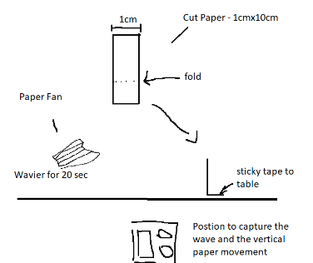

Write-up (on paper):
Predict which fan design makes the paper move the most.
Record the results
Were you right?
Any surprises?
How does material stiffness affect the bend angle?
How does fan design influence air velocity and resulting paper movement?
How does distance from the fan affect bending?

 | Bend (in degrees) | Outcome (in degrees) | Observation Notes:  Were you right?
Design 1 (e.g. 1cm back and forward folds) | 30º
Design 2 (e.g. no folds)
Design 3

Discussion
Moving air applies force to objects. Paper bends due to flexibility (plasticity), and repeated bending can weaken it.

Tip: Approximate force using $F≈k⋅θ$. Students can rank forces by stiffness and bend angle without exact units if needed.

Optional Challenge
- Estimate a stiffness coefficient $k$for each material by measuring bend angle under a constant fan speed.

1. What $k$ is
For bending a sheet of paper:
$$F≈k⋅θ$$
- $F$= force applied (N)
- $θ$= bend angle (radians)
- $k$= stiffness coefficient, representing resistance to bending
In reality, $k$is related to flexural rigidity $D=\frac{Et^{3}}{12(1-ν^{2})}$, but for classroom experiments we can use approximate empirical values.

2. Approximate $k$values for different papers
Material | Thickness (mm) | Stiffness k (N/rad) | Notes
Thin printer paper | 0.1 | 0.05 | Bends very easily
Standard card stock | 0.25 | 0.2 | Moderate bend
Thin cardboard | 0.5 | 0.5 | Much harder to bend
Corrugated cardboard | 3 | 2–3 | Very stiff, almost no bend
These are rough classroom values to let students estimate forces. The point is to see relative differences between materials.

3. Example calculation
Suppose:
- Thin paper, $k=0.05\text{ N/rad}$
- Bend angle observed: 30° → $θ={30}^{∘}≈0.524\text{ rad}$
$$F≈k⋅θ=0.05⋅0.524≈0.026\text{ N}$$
- For thicker cardboard, $k=0.5$, same bend angle:
$$F≈0.5⋅0.524≈0.26\text{ N}$$
So, the force required increases strongly with stiffness.

Curriculum Links
- ACSSU076 – Forces and motion

Activity 4: Earthquake-Resistant Structure
(Engineering + Earth Science)
Overview
Students design structures that withstand vibration, simulating earthquakes.
Equipment
- Cardboard, paper, scissors, sticky tape, plastic/paper cups.
- Mobile phone with vibration sensor
Instructions
- Build an anti-vibration layer, by folding paper/cardboard.
- Place a flat cardboard platform on top.
- Place the phone in the centre and activate vibration mode on the STEMM App.
- Modify the structure to reduce movement (e.g. more pillars, more folds, etc)
Diagram
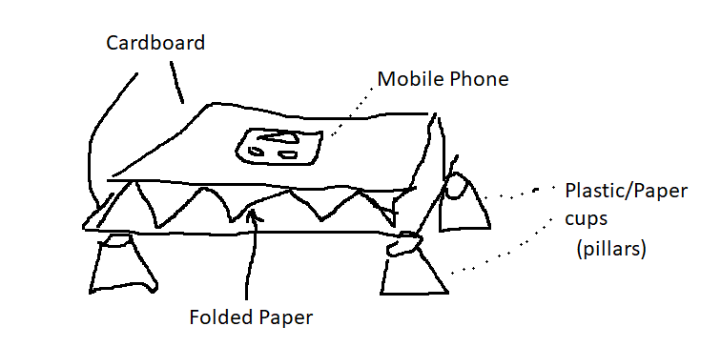

Write-up (on paper):
Predict which fold design makes the phone move the least.
Record the results
Were you right?
Any surprises?

 | Phone moves | Outcome (in degrees) | Were you right?
Design 1 (e.g. 4 folds + 4 pillars) | e.g. +/- 1cm | 4cm
Design 2 (e.g. 10 folds + 4 pillars)
Design 3 (e.g. 3 folds and 6 pillars)

Discussion
Earthquakes cause ground vibrations that can collapse poorly designed structures. Engineers design buildings to absorb and distribute energy safely.
Curriculum Links
- ACSSU096 – Earth processes
- ACTDEP036 – Testing and improving designs

Health and Medical Sciences

Activity 5: Human Performance Lab – Stretch Speed & Gracefulness
(Medical Science + Biomechanics)
Overview
Students investigate how the human body moves by measuring speed, smoothness, and coordination during controlled stretching activities.
Equipment
- Mobile phone with STEMM Lab app
- Open space to move safely
Instructions
- Hold the phone firmly in one hand. Activate the App vibration sensor.
- Perform guided movement slowly as shown in the app. Record the vibration.
- Repeat the activity with vibration feedback enabled.
- Review speed, smoothness, and range-of-motion data.
- Upload results and reflect as a group.

Diagram
- Student holding phone
- Direction of movement arrows
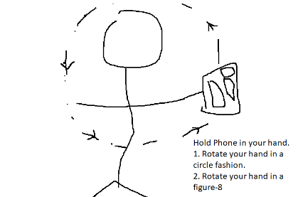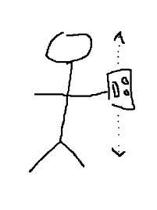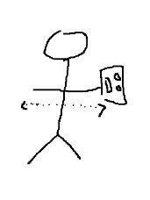
Movement 1 Movement 2 Movement 3

Write-up (on paper):
Which movement was the hardest to keep the vibration low?
Record the results
Were you right?
Any surprises?

 | Predict Phone Vibration Sensor (absolute) | Outcome (time + movement) | Were you right?
Attempt 1 | e.g. +/- 1cm | 5 mm in 20 seconds
Attempt 2 |  | 5 mm in 5 seconds
Attempt 3

Discussion (Plain Language)
Muscles and joints work together to create movement. Faster movements often reduce control, while smoother movements show better coordination. Sensors in the phone measure how quickly and smoothly the body moves, helping students understand biomechanics and fatigue.
Curriculum Links
Health & Physical Education
- ACPPS051 – Movement skills
- ACPPS054 – Physical performance
Science (Biology)
- ACSSU176 – Structure and function of body systems

Activity 6: Reaction Board Challenge
(Neuroscience + Mathematics)
Overview
Students measure reaction time, coordination, and improvement through repeated digital and physical challenges.
Equipment
- Mobile phone with STEMM Lab app
- Clear working space
Instructions
Phase 1 – Tap Reaction
- Tap the screen as soon as the hidden button appears.
- Record reaction time.
Rotate through each team member
Phase 2 – Swap Hands
3. Repeat using the non-dominant hand.
4. Compare results.
Rotate through each team member

Phase 3 – Tracing Challenge
5. Trace a moving shape on the screen.
6. Review accuracy and delay.
Rotate through each team member
Diagram
- Phone screen with reaction button
- Tracing path illustration
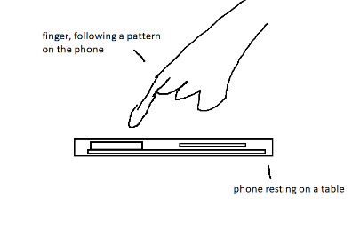
Write-up (on paper):
Predict your reaction time.
Record the results
Were you right?
Any surprises?

 | Reaction Time Prediction | Outcome (time + movement) | Were you right?
Attempt 1 | e.g. +/- 1cm | 6 seconds delay
Attempt 2 |  | 3 seconds delay
Attempt 3

Discussion (Plain Language)
Reaction time measures how quickly the brain processes information and sends signals to muscles. Practice can improve speed and coordination. Comparing hands shows how dominance affects performance.
Curriculum Links
Science Inquiry
- ACSIS130 – Collecting and analysing data
Mathematics
- ACMSP147 – Averages and variation
Health
- ACPPS057 – Understanding physical performance

Activity 7: Breathing Pace Trainer
(Medical Science)
Overview
Students analyse breathing patterns at rest and after exercise.
Equipment
- Mobile phone with STEMM Lab app
- Flat surface or mat
Instructions
- Place the phone gently on the chest.
- Record breathing at rest.
- Perform light exercise.
  - Jog one minute on the spot
  - 100 star jump
- Record breathing again and compare results.
Rotate for each team member
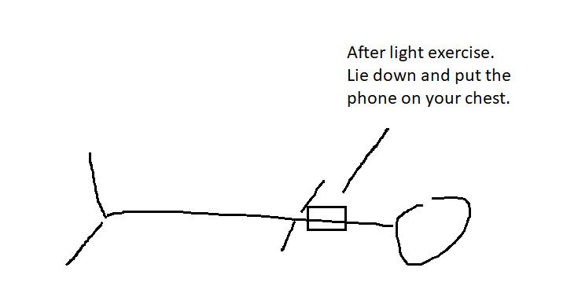

Write-up (on paper):
Predict which fold design makes the phone move the least.
Record the results
Were you right?
Any surprises?

 | Predict Breathe per minute | Outcome (time + movement) | Were you right?
Breathing at Rest | e.g. 6 breath per minute
After Exercise 1
After Exercise 2

Discussion
Breathing rate increases during exercise to supply more oxygen to muscles. Sensors detect chest movement, helping students visualise breathing patterns.
Curriculum Links
- ACSSU176 – Body systems
- ACPPS054 – Physical activity and health

